On-Line Registration & Waiver Form - $20 per dog
13th Annual Wiener & Small Dog Races on Colony Days
Saturday October 2nd, 2021 – Atascadero Sunken Gardens – Rain or Shine
Check-in 10:00 am to 11:30 pm – Heat Races start at Noon & finals about 1:00 pm
Waiver Liability Agreement Form: Wiener and Small Dog Races, October 2nd, 2021
By signing below, I agree to the following 4 aspects associated with these dog races.
1) I am aware that the dog races are a potentially hazardous activity, I am voluntarily participating, and agree to assume all risks of injury or property damage to myself or my dog.
2) As a consideration for being permitted to participate in these dog races, I hold harmless the “Event Organizers” which include the City of Atascadero, Lemos Feed and Pet Supply, Heilmann Dog Park, and any other organization assisting in producing this event.
3) I authorize the Event Organizers to use my photograph and name, free of charge, for any promotional purposes regarding these dog races.
4) I agree to abide by the rules set forth regarding these dog races & fully understand the race judges decisions are final and that this agreement is a complete release of liability for any incident whether by unintended negligence or accident.
Signature: _______________________________Date:_______________________
Dog Owner (Please Print Clearly):________________________________________ Phone:_______________ email:_________________________________________
Address:____________________________________________________________
Please Print out Form & Mail with check to “SLOPOST/Heilmann Dog Park” - $20 per Dog
7343 El Camino Real, #335, Atascadero, CA 93422”
Dog Registration on Race Day is OK, from 10am - 11:30pm but it’s helpful if the form is mailed by Sept.15.
 | DOG 1 | DOG 2 | DOG 3
DOG NAME
WIENER DOG
SMALL DOG(<25lbs)
Describe your dog(s) interests & characteristics to be announced to the spectators.

Dog 1

Dog

Dog

All racers will compete in randomly assigned heats. Two winners will advance from each heat.
2 Race Divisions: 1 Wiener Division, 1 Small Dog Division (under 25 lbs)
Dog Race Event Rules are detailed on the other side!
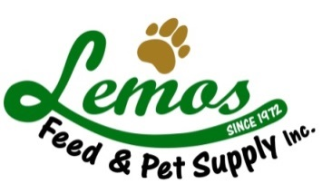
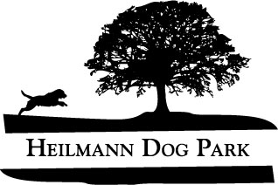
DEBBIE ARNOLD
5TH DISTRICT
SLO SUPERVISOR

OFFICIAL DOG ENTRY #: WIENER #_________ SMALL DOG # __________
Note: All entries will obtain a “Goody Bag” of dog toys & dog items donated by Lemos.
All entries will be given a raffle ticket for a chance to win a “Falconry Experience”. (www.flalconryexperience.com)

Dog Race Event Rules

The race track is 12’ wide and 32’ long with lane dividers to allow for up to six racers at a time. The track is surrounded by fencing to separate dogs and racers from spectators. Dogs may be off-leash in the track area but must be kept on-leash at all times outside the track.

The rules are presented at the beginning of each heat by the race judge. Volunteers will be available to provide any assistance that you might need.
- Only Dachshunds may enter the Wiener Dog Race. Proof of dachshund pedigree is not required however your dog must look like a dachshund.
- The small dog division is open to any breed of dog under 25 pounds in weight.
- All dogs must have two handlers for the event. One handler will release the dog at the starting line and one handler will “catch” the dog at the finish line.
- Dogs must be held at the starting line until the whistle is blown to start the race. No “throwing” of the dogs onto the track is permitted.
- Do not release the dog before the whistle is heard as a 2nd false start will disqualify the racer.
- Lane jumping at any point on the track will disqualify a racer.
- Handlers at the finish line must remain behind the line & cannot reach into the track to catch their dog.
- The number of heats will be determined by the number of racers. Typically, the top 2 racers in each heat will advance to the next round. In case of a tie or other special circumstance such as if a racer is cut-off, more than 2 racers may advance to the next round.
- Dog handlers at the finish line can bring a toy to entice their dog. No food is allowed in the race area. Please be considerate of the others in your choice of motivation for your dog. No object may be tossed down the track.
- The judges’ decisions are final.

A trophy and gift basket is planned to be awarded to the 1st & 2nd place finishers of the finals for each division.
The gift basket filled with many dog items is donate d by Lemos.

